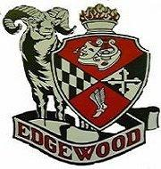
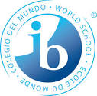
Edgewood High School
2415 Willoughby Beach Road
Edgewood, Maryland 21040

Please sign and date below indicating:

We have read and understand the information in the GSIB Academic Honesty Policy document that has been shared with both me and my child.

We understand that academic honest is something that is taken very seriously in the GSIB Program and at Edgewood High School.

Student name: _____________________________________________________________

Student signature: __________________________________________________________

Date: ____________________________

Parent name: _____________________________________________________________

Parent signature: __________________________________________________________

Date: ____________________________

This form will be kept on record for the duration of enrollment in the GSIB program.

Please return this form to Mrs. Childs – thank you.

